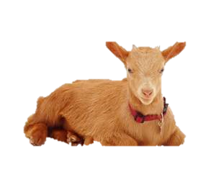 Name:

Livestock Breeds Display Project

Objective: You will display and describe your favorite breed of swine, sheep, goats, beef cattle, and dairy cattle.

* In order to complete your poster, you will design a Piktochart or Canva (<https://www.piktochart.com/>) (<http://www.canva.com/>) that incorporates images and descriptions of each breed you select.
* Please use the following website from Oklahoma State University to find all your information and explore all the breeds. <http://www.ansi.okstate.edu/breeds/>
* Share your finished project with Mr. Hartfield by email, [hartfield.kevin@cusd80.com](mailto:hartfield.kevin@cusd80.com)

[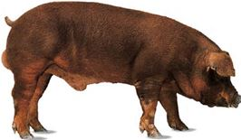](http://www.bing.com/images/search?q=duroc+pig&id=377D2E7405C6BE1D16FA3338E72214EE1809845D&FORM=IARRTH#view=detail&id=377D2E7405C6BE1D16FA3338E72214EE1809845D&selectedIndex=0)

NO COPY AND PASTE WORK WILL BE ACCEPTED!!

The following is a grading rubric for your project. TOTAL 55 points

|  |  |  |  |
| --- | --- | --- | --- |
| Requirement | Does not meet | Partially meets | Fully meets |
| 2 photos for each breed  (5 total)  (15 points) | 0-5 | 6-10 | 11-15 |
| 1 paragraph description  (5-7 sentences) for each breed  (5 total)  (15 points) | 0-5 | 6-10 | 11-15 |
| Color scheme/ theme  (9 points) | 0-3 | 4-6 | 7-9 |
| Grammar/spelling  (6 points) | 0-2 | 3-4 | 5-6 |
| Title and Breed Labels  (6 Total)  (10 points) | 0-3 | 4-6 | 7-10 |
| Score |  |  |  |

